
INTERNET PROGRAMMING AND MOBILE PROGRAMMING

PROJECT 3:
Design and Implementation of a Crowdsensed Drive Test Mobile Application for Coverage Prediction

TASK 2: REQUIREMENT GATHERING
GROUP 10

GROUP MEMBERS
 | Name of Member | Matricule
1 | Asangana Paul Fleming | FE23A014
2 | Fontem Junior Nkonganyik | FE23A063
3 | Suinyuy Mathias Mahla | FE23A144
4 | Nfor Godwill Kongnje | FE23A108
5 | Ronald Namwene Vefonge | FE22A295

Requirement Gathering

- Introduction
Requirement gathering is one of the most important stages in the development of the crowdsensed drive test mobile application for coverage prediction. This stage focuses on identifying all system stakeholders, understanding their expectations, and collecting the information necessary for successful system implementation. The crowdsensed drive test mobile application is designed to collect cellular network measurements from smartphones and use them for network coverage analysis and prediction of coverage holes.
Traditional drive testing approaches require expensive hardware and specialized vehicles. However, this project uses ordinary smartphones as sensing devices capable of collecting signal strength and location information while users move naturally from one place to another. Through crowdsensing, the system becomes scalable, cost-effective, and capable of covering larger geographic areas.

- Stake Holders Identification
Identifying stakeholders of any information system is a critical step in ensuring that the system meets real-world needs and operates effectively. Stakeholders are individuals, groups, or organizations that have an interest in the system, either because they contribute to it, use it, or are affected by its outcomes. Proper identification and understanding of stakeholders help in defining system requirements, improving usability, and ensuring successful adoption of the application.

In the context of the crowdsensed drive test mobile application for coverage prediction, there exist 3 set of stakeholders. They include;

2.1 Primary Stakeholders:
Primary stakeholders are those who directly interact with the system and are essential to its operation. They include;

2.1.1 Mobile Users(Crowdsensing Participants):
Mobile users are the backbone of the system, as they provide the crowdsensed data required for coverage analysis. These users install the mobile application on their smartphones, which automatically collects network performance metrics such as signal strength, network type, and geographic location. Their participation determines the volume, diversity, and quality of data collected. Without sufficient user participation, the system cannot effectively predict coverage or identify coverage holes.

2.1.2 Network Operators:
Telecommunication companies such as MTN, Orange, and Camtel are key stakeholders because they benefit directly from the insights generated by the system. The analyzed data helps them identify weak coverage areas, optimize base station placement, improve service quality, and enhance overall network performance.

2.1.3 System Administrator:
System administrators are responsible for managing the backend infrastructure of the application. They oversee data storage, system performance, and security. Their role includes monitoring incoming data streams, ensuring system availability, handling errors, and generating reports for stakeholders such as network operators and researchers. They ensure that the system operates reliably and efficiently.

2.2 Secondary Stakeholders
Secondary stakeholders do not directly interact with the system on a daily basis but are significantly impacted by its outputs. Some of these set of stakeholders include;

2.2.1 Regulatory Authorities:
Regulatory bodies such as the Cameroon Telecommunications Regulatory Board play an important role in overseeing the telecommunications sector. These organizations ensure that network providers meet established Quality of Service (QoS) standards. The data and insights generated by the system can support regulatory monitoring, policy development, and enforcement of compliance among network operators.

2.2.2 Developers And Researchers:
Developers are responsible for designing and implementing the mobile application, backend systems, and data analytics modules. Researchers, on the other hand, analyze the collected data to develop models for coverage prediction and coverage hole detection. These stakeholders rely heavily on high-quality data and system performance to achieve accurate and meaningful results.

2.3 Tertiary Stakeholders
Tertiary stakeholders are indirectly affected by the system and may not be immediately visible but still play a role in its ecosystem. They include;

2.3.1 The General Public:
The general population benefits from improved network coverage resulting from the system’s analysis. Even individuals who do not use the application directly may experience better connectivity as network operators optimize their infrastructure based on crowdsensed data.

2.3.2 Government And Policy Makers:
Government agencies and policy makers can use insights from the system to make informed decisions about digital infrastructure development, rural connectivity initiatives, and national communication strategies. The data supports evidence-based policy making.

2.3.3 Device Manufacturers And O.S Providers:
Companies that develop smartphones and operating systems indirectly influence the system through the APIs and hardware capabilities they provide. The accuracy and availability of sensor data depend on these technologies.

- The system operates through continuous interaction among stakeholders. Mobile users generate data, which is processed by the backend system managed by administrators. The processed data is then analyzed and used by network operators and researchers to improve coverage. Regulatory bodies use the insights to enforce standards, while the general public and organizations benefit from improved network services. This interconnected relationship ensures that the system remains functional, relevant, and impactful.

- Stakeholder identification in the crowdsensed drive test mobile application highlights the diverse range of participants involved in the system. From mobile users who generate data to network operators who utilize insights.Understanding these roles ensures that the system is designed to meet the needs of all parties, leading to effective implementation, improved network coverage, and enhanced user experience.

- Requirement Gathering Techniques
Multiple techniques can be used during requirement gathering to ensure that both technical and user-centered requirements are identified..

We made use of the google form format of the requirement gathering process we got the feed backs and proceed to clean and analyse the data. Other requirement gathering techniques involves

- Interviews are carried out with mobile users and telecommunications experts. These interviews provide deeper understanding of connectivity challenges and technical expectations.
- Brainstorming sessions among project team members help generate ideas for system features, offline storage, automated synchronization, battery optimization, and data visualization.
- Reverse engineering is performed on existing applications such as OpenSignal and nPerf. This helps identify useful features and limitations of current systems.

- Data Cleaning
The following survey insights image highlights raw user feedback that requires cleaning before analysis:

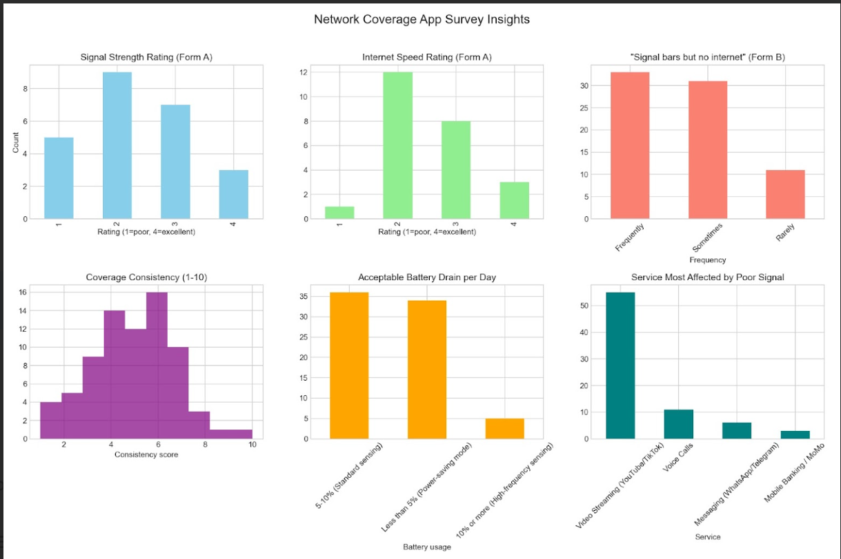
This process involve the following:
- Handling Inconsistencies: Some users may rate signal strength as poor but internet speed as acceptable. Cross-checking ensures logical consistency.
- Removing Duplicates: Multiple submissions from the same device or user must be duplicated.
- Standardizing Formats: Ratings (1–4 scale, 1–10 consistency scores) must be normalized for uniform analysis.
- Filtering Noise: Outliers such as unrealistic battery drain expectations (e.g., “0%”) or contradictory responses are flagged.

5. User Sentiment and Technical Environment
Based on the survey data analyzed from the provided resources, several key technical and behavioral trends have emerged among potential participants:

3.1 Device Ecosystem
- Operating Systems: A significant portion of the surveyed users utilize iOS 26, followed by various Android versions.
- GPS Usage: There is a mixed baseline for location services, with several users reporting they do not typically keep GPS enabled.

3.2 User Comfort and Preferences
Features | User Preference Trend
Acceptable Battery Drain | Majority favor 5-10% (Standard sensing)  or less.
Data Syncing | High preference for Immediate sync using mobile data.
Notification Type | Users prefer receiving a notification when entering a “dead zone”
Retention Incentive | High interest in a “Live Signal Map” feature.

3.3 Network Pain Points
Users frequently report experiencing signal bars while being unable to load internet pages, particularly affecting Video Streaming (YouTube/TikTok) and Voice Calls. Coverage consistency ratings indicate significant room for mapping improvements.

4. Conclusion and Next Steps
The data suggests that for the application to be successful, it must maintain a low battery footprint and provide immediate value back to the user via a live signal map. The stakeholder synergy between mobile users and operators is the critical path for task advancement.

